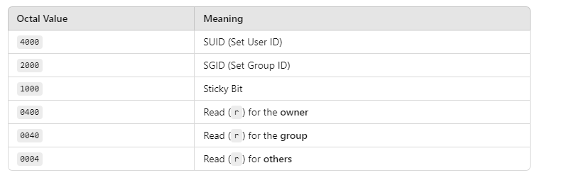

find / -perm /4000 2>/dev/null (hides errors)

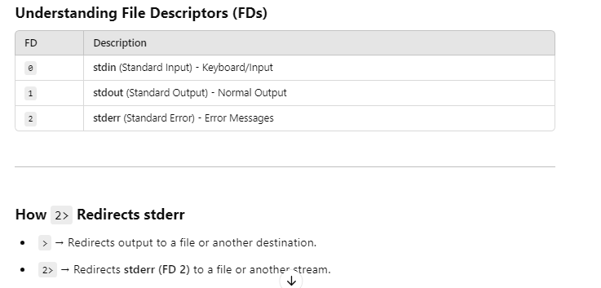

/dev/null is a special file in Linux that discards any data written to it. It is often called the "black hole" because anything sent to it disappears

www-data
It will display details about the www-data user, which is commonly used by web servers like Apache (httpd) or Nginx.

uid=33(www-data) gid=33(www-data) groups=33(www-data)
• Web servers run as www-data to isolate their privileges.
• If an attacker gains access to a web application, they might execute commands as www-data, which typically has limited system privileges.
• If SUID binaries or misconfigured files are writable by www-data, it could be a privilege escalation vector.

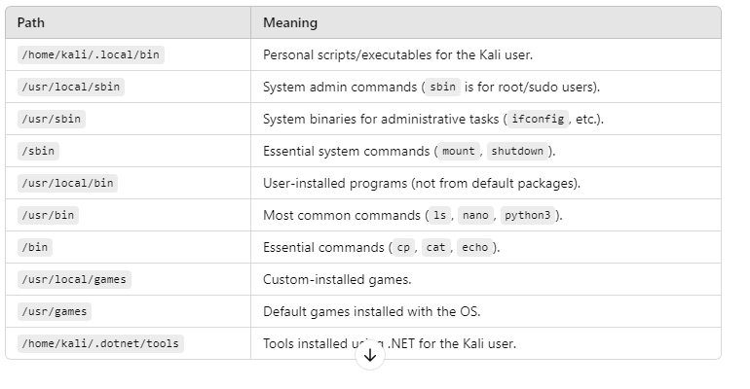
echo $PATH
/usr/local/sbin:/usr/local/bin:/usr/sbin:/usr/bin:/sbin:/bin
export PATH=/tmp:$PATH
echo $PATH
/tmp:/usr/local/sbin:/usr/local/bin:/usr/sbin:/usr/bin:/sbin:/bin

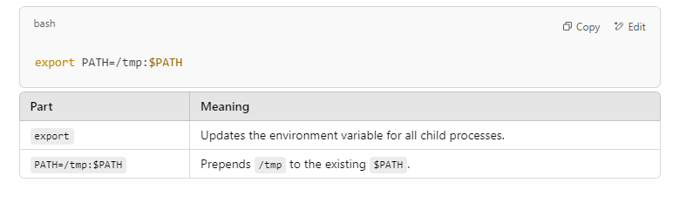

echo ‘#!/bib/bash’
echo “uid=33(think) gid=33(think) groups=33(think)”

